CHAPTER IV
RESULT AND DISCUSSION

- The Research Procedure
The research was conducted in July 23th, 2018. Before conducting the research, the researcher asked the headmaster and the English teacher for permission at the school. After getting the permission, the researcher conducted through the following steps:

a. Determining the subject of the research, namely students at the first semester of the ninth grade of SMP Muhammadiyah 3 Bandar lampung.
b. Preparing try-out, The researcher prepared a kind of test (called try-out test) that were be given to the students in IX C on July, 27th 2018. The researcher prepared try-out test for pre-test and post-test. Then the researcher evaluate the test items that were tested in pre-test and post-test.
c. Preparing pre-test, The researcher prepared a kind of test (called pre-test) that was given to the students.
d. Determining the material to be taught,The researcher determined the material to be taught to the students that is reading comprehension of report text.
e. Preparing post-test, The researcher prepared a kind of test (called post-test) that were given to the students. By giving post-test, the researcher known whether the students can improve their reading ability in comprehending English text or not.
f. Analyzed the data gotten through post-test. The data were analyzed by using statistic formula.
g. Tested the hypothesis and made the conclusion.
h. Reported the result of the research.

- Research Findings
The research was aimed to know wether there is significantinfluence of using semantic mapping strategy towards students reading comprehension in report text of the first semester at SMP Muhammadiyah 3 Bandar Lampung in the academic year of 2018/ 2019. The total number of the sample was70 students, two classes were chosen as control class and experimental class.
The instrument of this reaserch was test. Pre-test consisted of 20 multiple-choice items with four options a, b, c, and d. then post-test consisted of 20 multiple choice items with four options a, b, c, and d. Pretest was conducted previously on july 30th, 2018 at 10.55 until 11.35 a.m for class IX F as the experimental class and on August 3nd, 2018 at 07.15 until 08.35 a.m for class IX E as the control class. The pre-test was administrated in order to see the students’ score in reading comprehension before they treatment.
After conducting the two meetings of using semantic mapping strategy, the researcher gave the posttest to the sample. The posttest was conducted on 20th, 2018. The post test was administered in order to see the students’ score in reading comprehension after the treatment.
- Result of Pretest in Experimental Class
The researcher conducted pretest in order to know students’ ability before the treatment. The pretest administrated on july 30th2018. The scores of students’ report text tested in pretest in the experimental class could be seen figure 2.
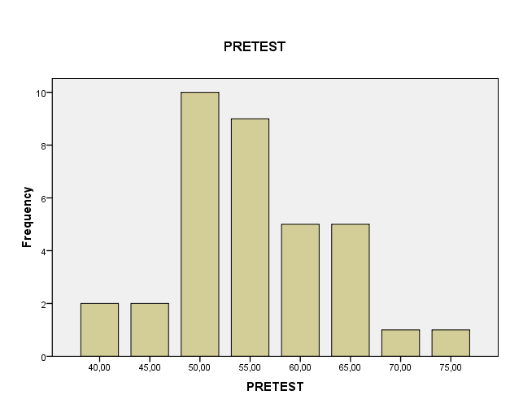

Figure 2
Ghraps of the Result of the Pre-test in Experimental Class

Based on figure 1, the mean of pre-test in experimental class was 55.00, and standar deviation on this figure was 70.00, N was 35, median was 55.00, variance was 65.00, and minimum score was 40.00, maximum was 75.00. it showed students reading comprehension of report text before they got treatmens.

- Result of Pre-test in Control Class
The researcher conducted pre test in order to know students’ ability before the treatment. The pre-test administrated on july 30nd ,2018. The scores of students reading tested in pre test in the control class could be seen in figure 3.
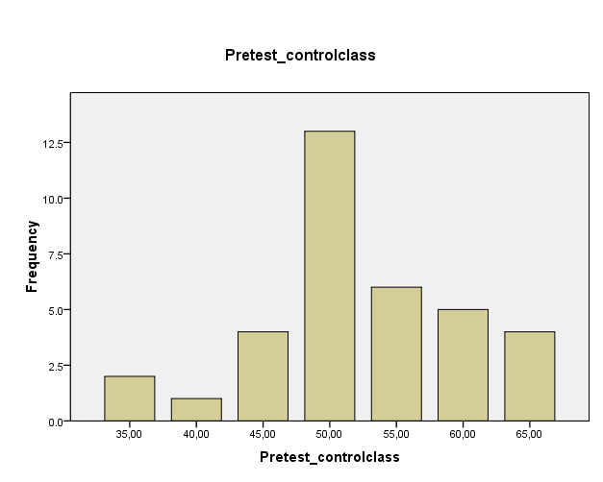
Figure 3
Ghraps of the Result of the Pre-test in Control Class

Based on the table 10, it could be seen that N of pretest in experimental class was 35, maximum score was 65, minimum score was 35, mean of pre-test in control class is 52,29, mode was 50, median was 50, variance was 62,69, and standard deviation was 7,89. It showed students’ reading ability before they got the treatments.

- Result of Post-test in Experimental Class

The researcher also gave post-test in experimental class to know students’ report text after the treatment. It was administrated on August 20th, 2018. The score of post-test in experimental class are presented in figure 4.
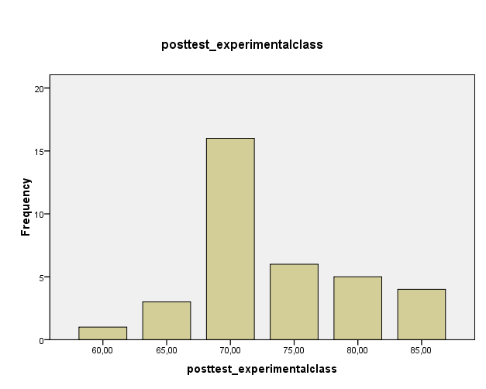Figure 4
Graphs of the Result of the Post-test in Experimental Class

Based on figure 4, it could be seen that N of post-test in experimental class was 35, maximum score was 85, minimum score was 60, mean of post-test in experimental class 73,29, mode was 70, median was 70, variance was 39,62, and standard deviation was 6,295. It showed sudents’ reading ability after they got the treatments.

- Result of Post-test in Control Class
The researcher also gave post-test in control class to know students report text after the treatment. It was administrated on August 20th, 2018. The score of post-test in control class are presented in figure 5.
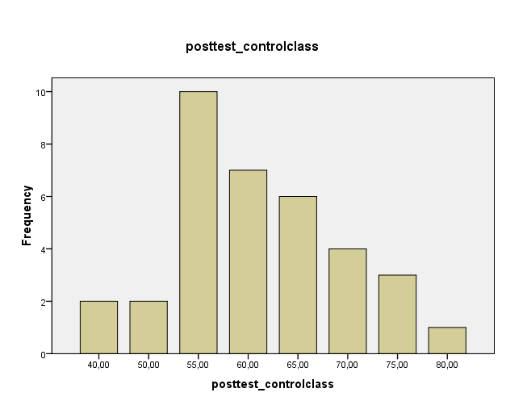
Figure 5
Graphs of the Result of the Post-test in Control Class

Based on figure 5, it could be seen that N of post-test in control class was 35, maximum score was 80, minimum score was 40, mean in control class 60,71, mode was 55, median was 60, variance was 84,03, and standard deviation was 9,17. It showed students’ reading ability after they got treatments.

- Data Analysis
After collecting the data, the researcher analyzed the data by using independent sample t-test. There were two assumption that were done, before the researcher analyzed the data by using t-test.

- Fulfillment of the assumption
Parametric statistical significance tests, such as analysis of variance and least squares regression, are widely used by researcher in many disciplines, including statistic parametric test to produce accurate result, the assumption underlying them such as normality and homogenity test must be satisfied.
- The Result of Normality Test
The normality test is used measure weather the data in the experimental class and control class are normally distributed or not.
The hypothesis formulas are:
Ho = the data have normal distribution.
Ha = the data do not have normal distribution.

The criteria of acceptence or rejection of the hypothesis for normality test were:
Ho is accepted if Sig. (Pvalue) > α = 0.05
Ha is accepted if Sig. (Pvalue) < α = 0.05

Table 10
The Result Normality Test of the Experimental and Control Class

Class | Kolmogorov-Smirnovª |  |  | Shapiro-Wilk
 | statistic | Df | Sig. | Statistic | Df | Sig.
Experimantal  Control | .271 | 35 | .065 | .890 | 35 | .059
 | .214 | 35 | .053 | .971 | 35 | .065
- Lilliefors Significance Correction

Based on Table 6, it can be seen that Pvalue (Sig.) for experimental class was 0,056 and Pvalue (Sig.) for control class was 0,01. Because sig. (Pvalue) of experimental class > α 0.05. so, Ho is accepted and sig. (Pvalue) for the control class > α 0.05. So, Ha is rejected. The conclusion is that the data in the experimental class amd control class had normal distribution. (See Appendix 14)
- The Result of Homogenity Test

After know the normality the data, the researcher was calculated the homogenity test to know the data homogeny or not.
Table 11
The Result Homogenity Test
 | Levene  Statistic | Df1 | Df2 | Sig.
Score Based on Mean | .975 | 1 | 68 | .327

Based on the result obtained in the test of homogenity of variances in the coloumn, it could be seen that sig. (Pvalue)= 0,327 > α = 0,05. It demostrated that Ho was accepted because Sig. (Pvalue) > α = 0.05. It means that the variance of the data was homogenous. (See appendix 15)
- The Result of Hyphotical Test
Based on the previous explanation that the normality and homogenity test were satisfied. Therefore, the researcher used the hypotetical test using SPSS ( Statistical Program for Social Science, independent sample t-test.
The hypothesis formulas are:
Ha :There is an influence of using semantic mapping strategy towards students’ reading comprehension of report text at the ninth grade of SMP Muhammadiyah 3 Bandar Lampung in the academic year of 20182019.
Ho :There is no influence of using semantic mapping strategy towards students’ reading comprehension of report text at the ninth grade of SMP Muhammadiyah 3 Bandar Lampung in the academic year of 20182019.
The criteria of acceptence or rejection of the hypothesis for hypothical test were:
Ho is accepted if sig. (Pvalue) > α = 0.05
Ha is accepted if sig. (Pvalue) < α = 0.05
Table 12
The Result of Hypothetical test
T | Df | Sig. (2-tailed)
6,501 | 68 | .01

Based on the results obtained in the independent sample t-test in Table 8, that the value of significant generated Sig.(P$value)$ = 0,01 < α = 0.05. So, Ha is accepted and Ho is rejected. Based on the computation, it can be concluded that there was a significant influence of using semmantic mapping strategy towards students’ reading comprehension of report text at the first semester of the ninth grade of SMP Muhammadiyah 3 Bandar Lampung.

- Disscussion
At the biginning of the research, the researcher explained there were some procedures used to know students’ reading comprehension in report text. Some test were conducted to collect the data such as pre-test and post-test. The pre-test was administered to know students’ quality in reading comprehension in report text before they were given treatments by the researcher.

Based on the finding of the research, there is a significant influence of using semantic mapping strategy on the students reading comprehension in report text. It showed by conducted three times treatments. The treatment was administered from August 6th,2018 until August 13th,2018. At the first treatment, the researcher gave the example of semantic mapping and explained it to the students. They also had problems of making the related words about the topic. Then, the researcher asked the students to think what things that can be related to the topic.

At the second meeting, the problem happened at the first meeting is not too hard. The problem are some students still confused about the use of semantic mapping. Therefore, the researcher gave more example to solve the problem. Then, the students try to answer the question together.

At the last meeting, the researcher asked the students to make semantic mapping. Here, the students could comprehend the text by using semmantic mapping. Then, they answered the question well.

In doing the treatment at control class, the researcher found difficulties when the researcher asked the students to comprehending a text. At the first meeting, the problem happened was because they were difficult to understand the meaning. In order to solve that, the researcher asked the students to guess the meaning based on previous words. At second meeting, the students found difficulties in catching the point of the text. Those problems could be solved by guidance of the researcher. The researcher gave some examples and try to find the point of the text. At last meeting, the students found difficulties in answering best answer of some question. In order to solve that problem, the researcher gave more explanation about what the answer should they chose.

At the end of the research, post-test was administered on August 20th,2018. It was given to measure the improvement of students’ report text reading comprehension in both classes after the treatments done. The mean score of post-test in experimental class was 73.29 and the mean of post-test in control class was 60.71.

Based on the analysis of the data and the testing of hypothesis, the result of T-test null hypothesis (Ho) is refused and alternative hypothesis (Ha) is accepted. It means that is any significant influence of using semantic mapping strategy towards students’ reading comprehension of report text, so alternative hypothesis is accepted. After taught semantic mapping strategy the researcher concluded that semantic mapping strategy any significant influence of students’ reading comprehension in report text. By applying semantic mapping strategy, students was effective in enhancing the students’ performance in reading comprehension.

