THE INFLUENCE OFUSING SEMANTIC MAPPING STRATEGY TOWARDS
STUDENTS’READING COMPREHENSION IN REPORT TEXT
AT THE NINTH GRADE OF THE FIRST SEMESTER AT
SMP MUHAMMADIYAH 3 BANDAR LAMPUNG
IN THE ACADEMIC YEAR OF2018/2019.

A Thesis
Submitted as a partial fulillment of the Requirements for S1-Degree

By:
Nopalia Maretha
NPM.141104312

Study Program : English Education
Advisor : Prof.Dr.Idham Kholid, M.Ag.
Co-Advisor : Septa Aryanika, M.Pd.

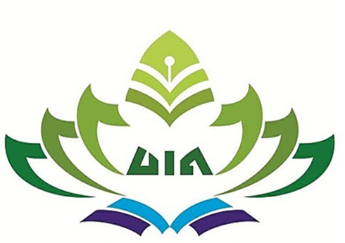

TARBIYAH AND TEACHER TRAINING FACULTY
RADEN INTAN STATE ISLAMIC UNIVERSITY
LAMPUNG
2018

